

**Setting up** **Go-Ethereum client**

**(Both Windows and Ubuntu)**

# Document History

|  |  |  |  |
| --- | --- | --- | --- |
| Date | Author | Version | Comment |
| 16-03-2017 | Balaji M | Draft | Initial Creation |
|  |  |  |  |
|  |  |  |  |
|  |  |  |  |
|  |  |  |  |

# Go-Ethereum

# What is Ethereum?

Ethereum is an open block chain platform that lets anyone build and use decentralized applications that run on block chain technology. Like Bit coin, no one controls or owns Ethereum – it is an open-source project built by many people around the world. But unlike the Bitcoin protocol, Ethereum was designed to be adaptable and flexible. It is easy to create new applications on the Ethereum platform, and with the Homestead release, it is now safe for anyone to use those applications.

It provides a decentralized [virtual machine](https://en.wikipedia.org/wiki/Virtual_machine), the Ethereum Virtual Machine (EVM). This virtual machine can execute Turing-complete scripts using an international network of public nodes and token called ether. Gas is used to prevent [spam](https://en.wikipedia.org/wiki/Spam) on the network and allocate resources proportionally to the incentive offered by the request

## Installation steps in ubuntu :

## Below are the prerequisites for installing go-ethereum on ubuntu:

List of Ubuntu packages:

* NPM
* NODEJS
* GIT
* CURL
* METEOR
* ETHEREUM USING GETH

## NPM

* Install the npm package using the below command:

|  |
| --- |
| sudo apt install npm |

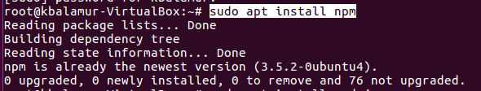

## NODEJS

* Install the nodejs package using the below command,

|  |
| --- |
| sudo apt install nodejs |

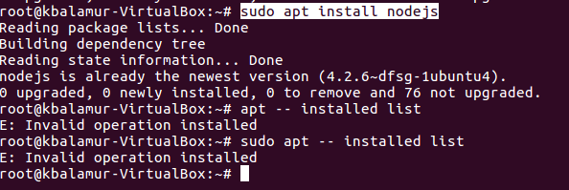

## GIT

* Install git package using the below command,

|  |
| --- |
| sudo apt-get install git |

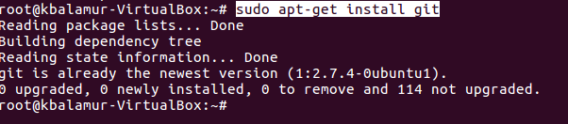

***CURL***

* Install the curl package using the below command,

|  |
| --- |
| sudo apt-get install curl |

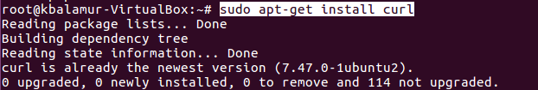

## METEOR

* Below is the command for installing meteor on ubuntu,

|  |
| --- |
| curl <https://install.meteor.com/> | sh |

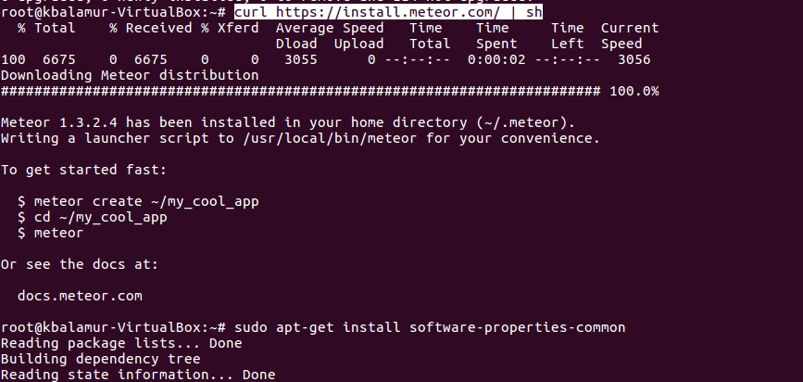

ETHEREUM USING GETH

## For installing ethereum we need to add below properties and repositories,

* Install the software-properties using below command,

|  |
| --- |
| $ sudo apt-get install software-properties-common |

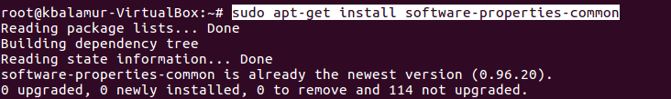

* Add the repositories for ethereum using below commands,

|  |
| --- |
| $ sudo add-apt-repository ppa:ethereum/ethereum-qt |

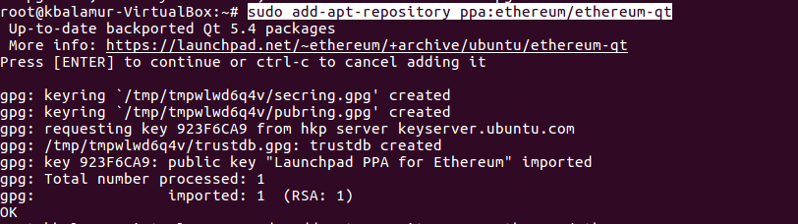

|  |
| --- |
| $ sudo add-apt-repository ppa:ethereum/ethereum |

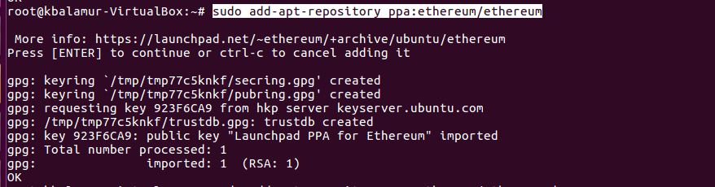

|  |
| --- |
| $ sudo add-apt-repository ppa:ethereum/ethereum-dev |

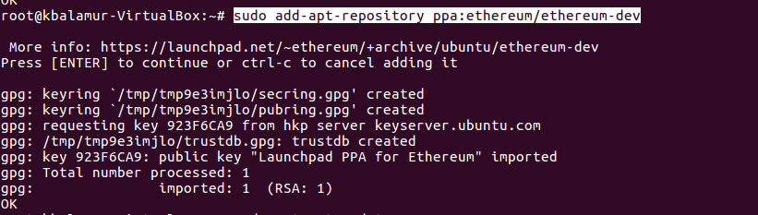

* After installing all the prerequisites, properties and repositories, run the below command for installing the ethereum on Ubuntu,

|  |
| --- |
| $ sudo apt-get install ethereum |

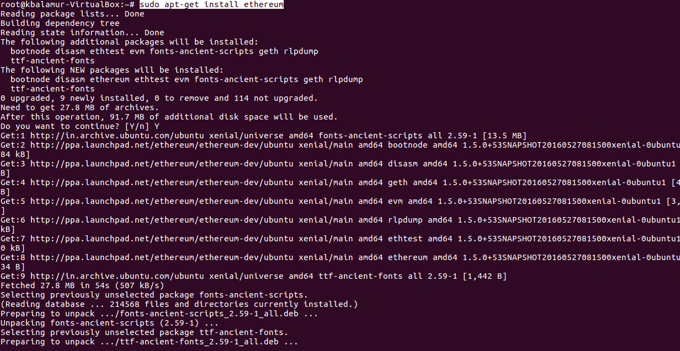

**Running the Ethereum:**

* Try running the below command for creating the account in go- ethereum,

|  |
| --- |
| $ geth account new ‘kesavan’ |

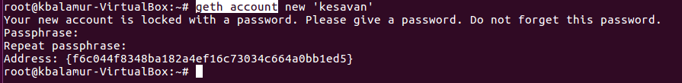

## Setting up of ethereum:

* Create a folder with name “datadir” and a file “genesis.json” as below,

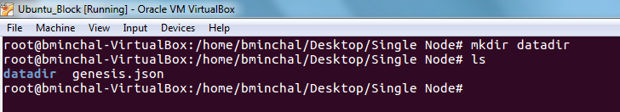

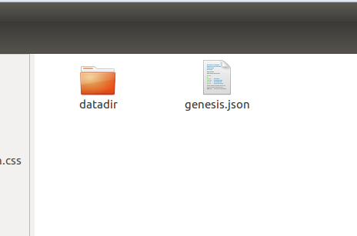

* Add the below data into genesis.json file,

|  |
| --- |
| {  "coinbase": "0x0000000000000000000000000000000000000000",  "config": {  "homesteadBlock": 5  },  "difficulty": "0x20000",  "extraData": "0x",  "gasLimit": "0x2FEFD8",  "mixhash": "0x00000000000000000000000000000000000000647572616c65787365646c6578",  "nonce": "0x0",  "parentHash": "0x0000000000000000000000000000000000000000000000000000000000000000",  "timestamp": "0x00",  "alloc": {  "0x6ca6134dec2753262d45aa4bc3e8eda43df872ff":{  "balance":"7555555555555771000000000000005555555555555550000000000222222"  },  "0x25e427270466263a6680dce0fcea214a041e9e25":{  "balance":"7555555555555771000000000000005555555555555550000000000222222"  }  }  } |

Note: add only the newly created account in the above json file.

* To initialize the geth run the below command,

|  |
| --- |
| $ geth --datadir <some/location/where/to/create/chain> init genesis.json |

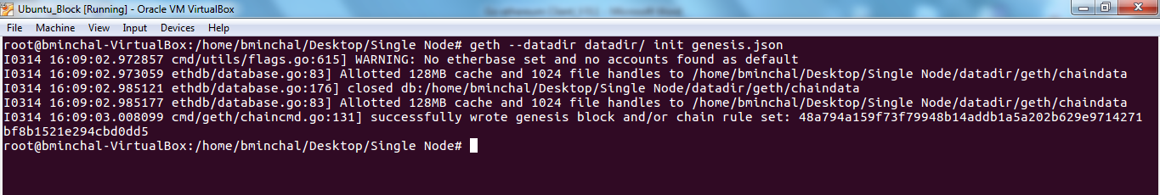

* The accounts should be created in newly created “data dir” folder as below,

|  |
| --- |
| $ geth --datadir datadir/ account new |

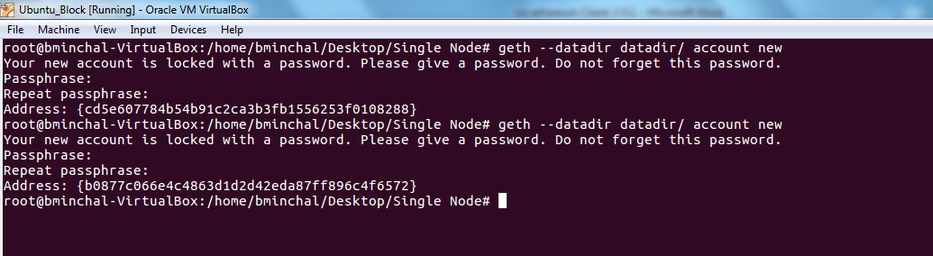

* Check the key value of your account number as below,

|  |
| --- |
| $ geth --datadir datadir/ console |

Geth –datadir datadir/ account list

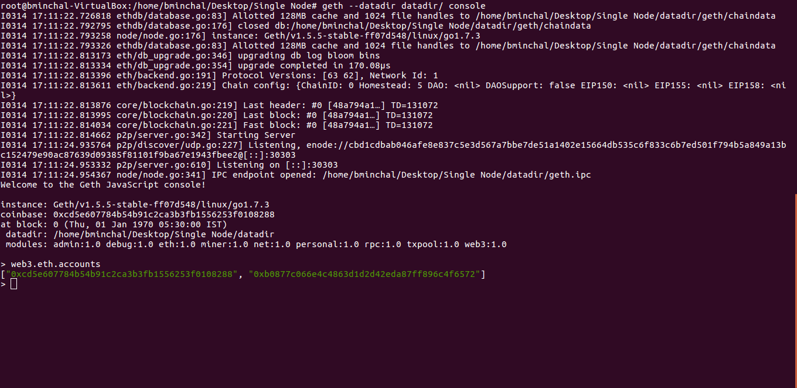

**Note:** By default truffle uses account with key ‘0’ .The newly created account number is under key “1” and truffle by default uses key “0”. So these accounts should be unlocked while running go-ethereum client.

* Run the below command for running private go-ethereum client under port “8545” using the data from newly created data directory “datadir/”,

|  |
| --- |
| geth --identity "PrivateNode" --rpc --rpcport "8545" --rpccorsdomain "*" --datadir "datadir/" --port "30303" --nodiscover --ipcapi "admin,db,eth,debug,miner,net,shh,txpool,personal,web3" --rpcapi "db,eth,net,web3" --autodag --networkid 1900 --nat "any" --etherbase " 0x80486bd34c1977ecec57963acc027a9805417fb4" --unlock 0,1 --mine |

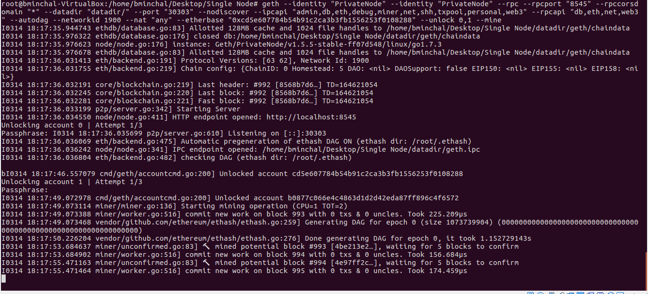

* It prompts for a password for both account keys 0 & 1, enter the correct password to unlock the accounts.
* After entering correct password it will display accounts unlocked as below,

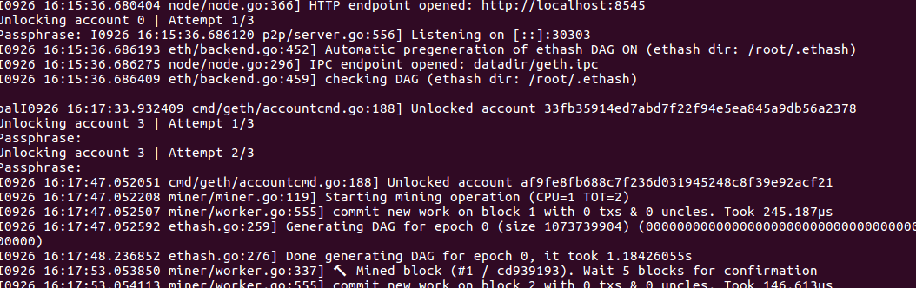

* Now the private ethereum should be running as below,

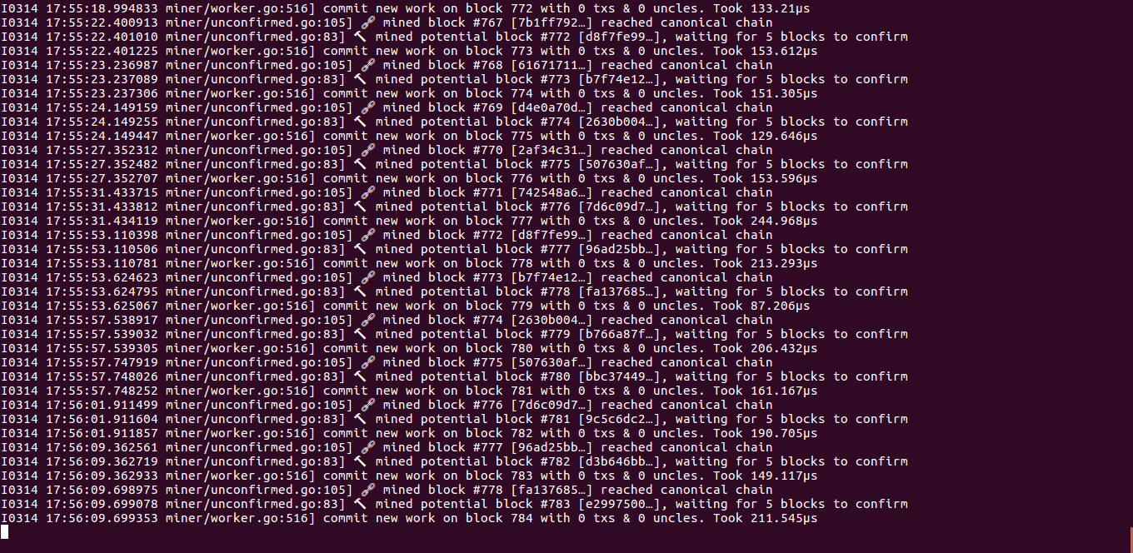

***Examples:***

Test the private ethereum with the below examples,



* Click on contract.html and create a contract as below,

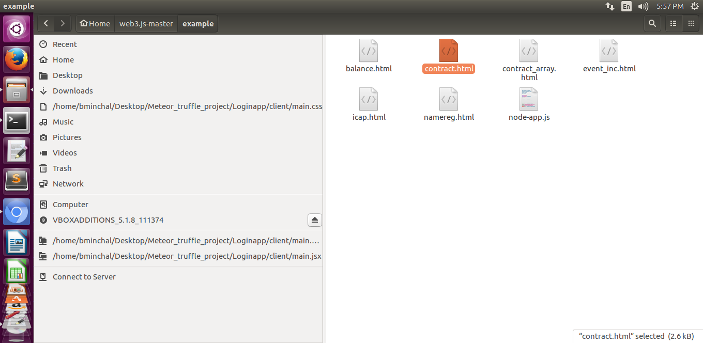

* Click on “create example contract” button to create a contract,

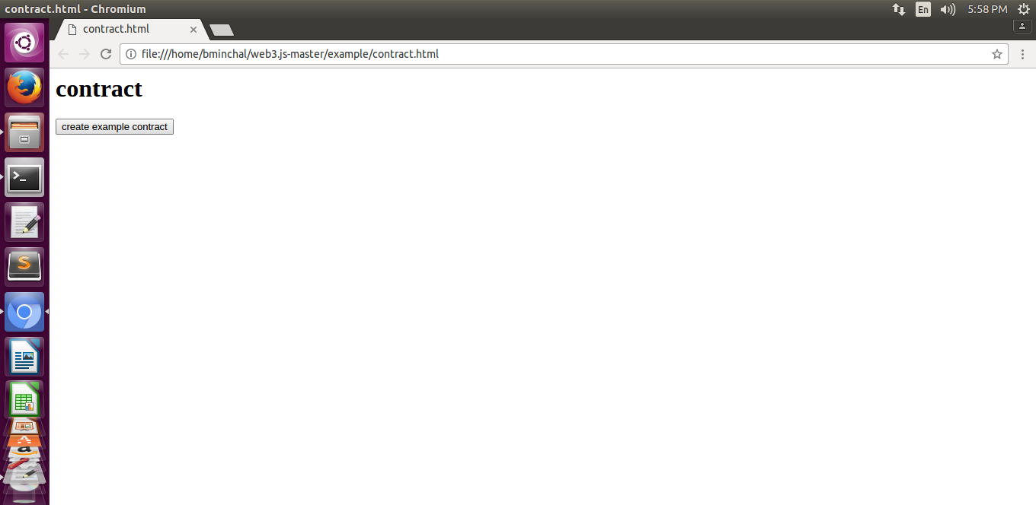

* After clicking on the button, immediately the below message will be displayed by creating a contract on ethereum blockchain,

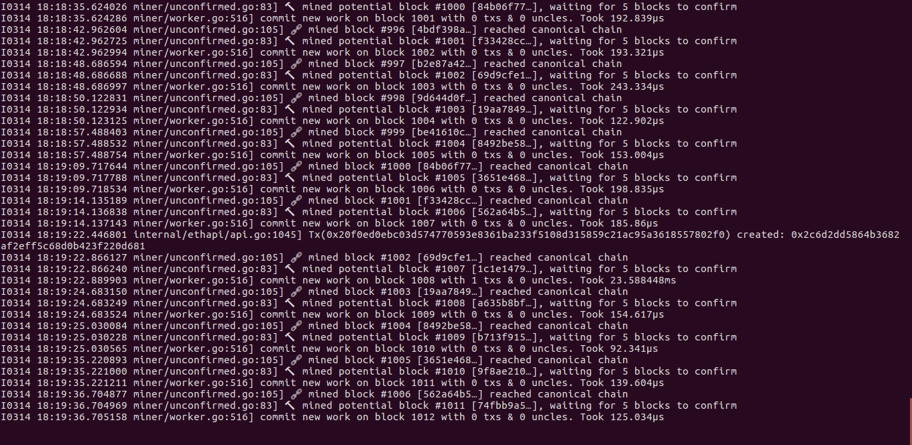

* The contract will be mined into blocks on ethereum blockchain, by displaying the below message.

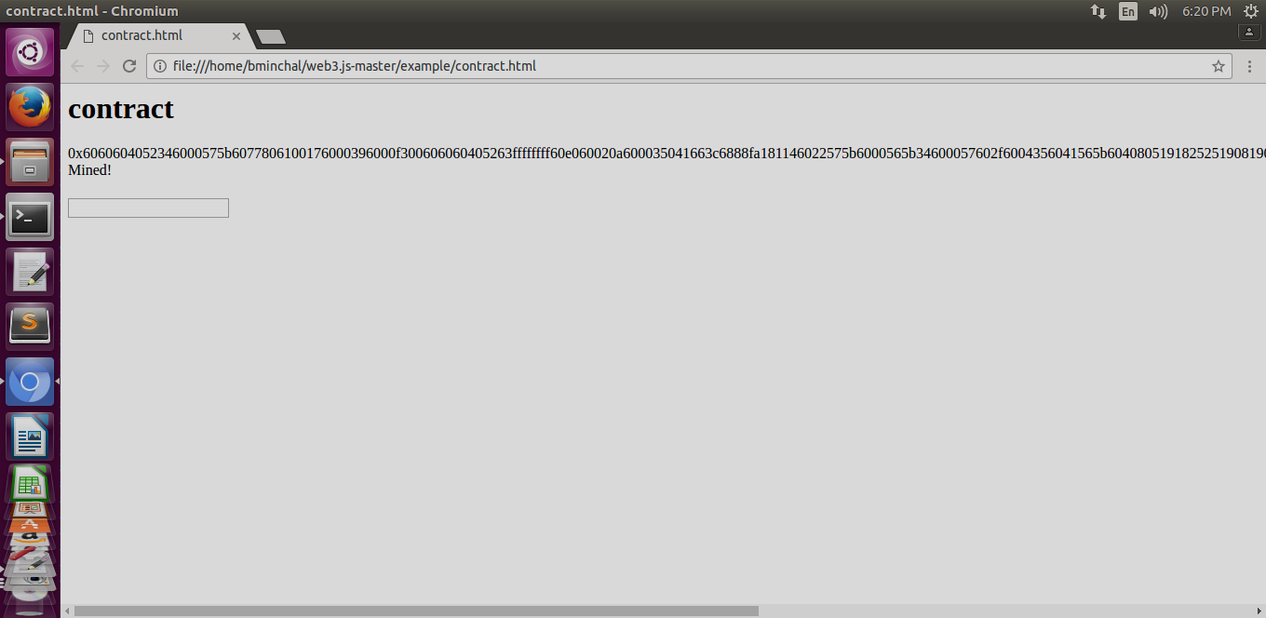

* Click on balance.html and check the balance of the account,

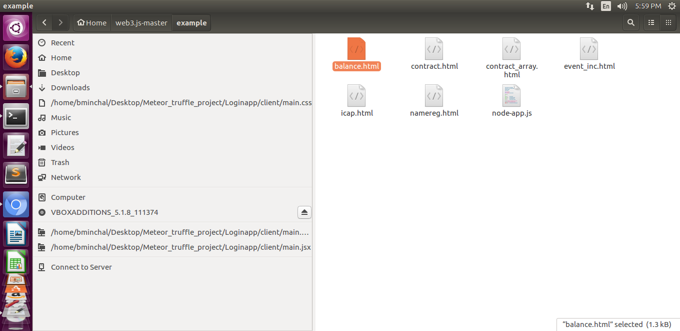

* Click on the “watch balance” button to get the balance on the account dynamically.

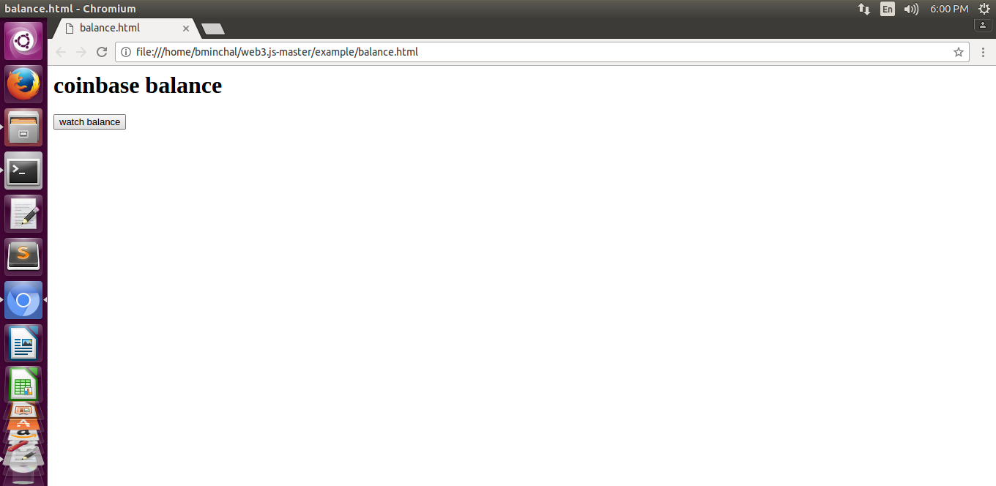

* The balance of the account will be changing based on the gas usage per ether.

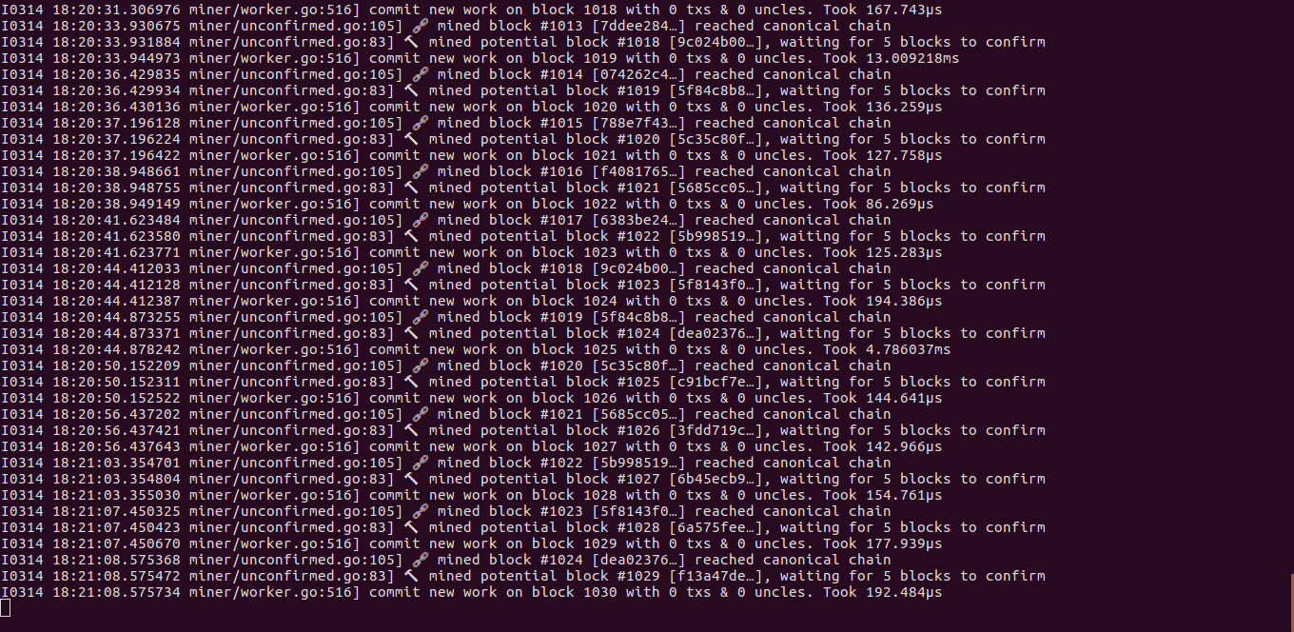

* Below is the balance of the account which will be varying dynamically.

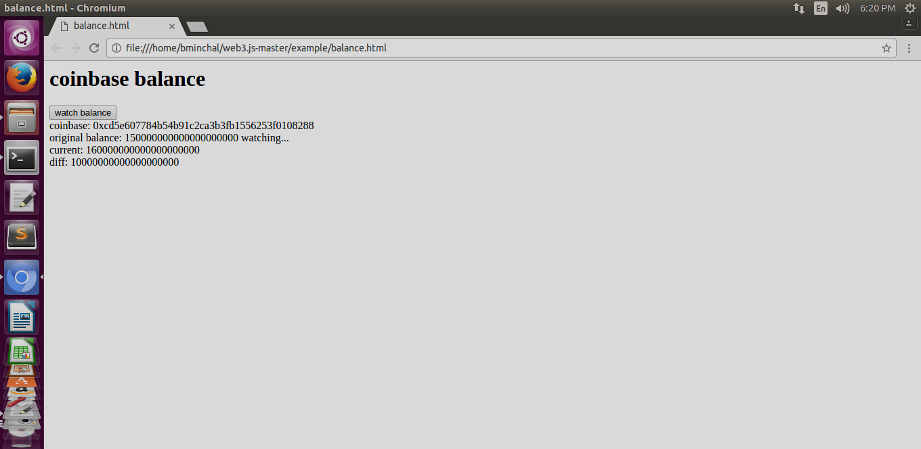

## Running Multiple Nodes on local network and connecting each other:

***Prerequisites:***

* Create two new folders as “datadir_India” and “datadir_USA”,

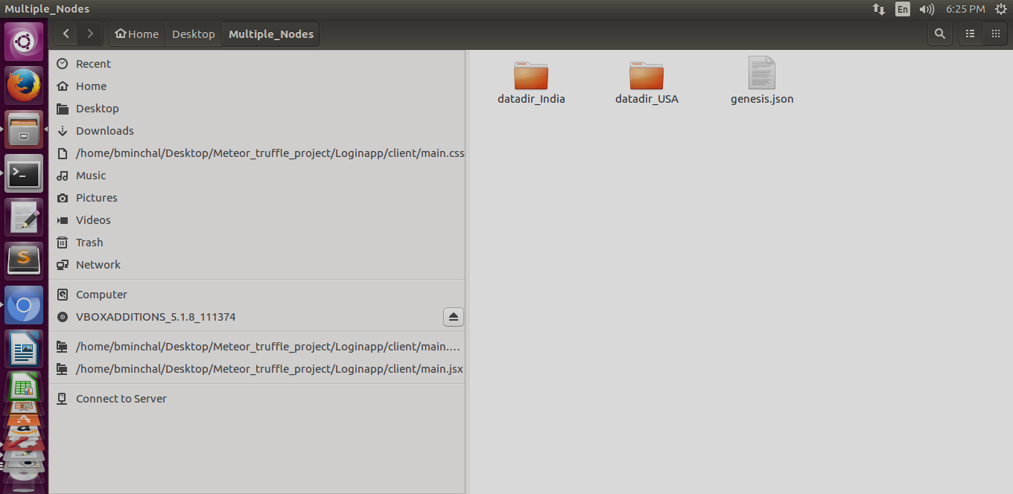

* Create a common genesis.json file for both nodes as below,

|  |
| --- |
| {  "coinbase": "0x0000000000000000000000000000000000000000",  "config": {  "homesteadBlock": 5  },  "difficulty": "0x20000",  "extraData": "0x",  "gasLimit": "0x2FEFD8",  "mixhash": "0x00000000000000000000000000000000000000647572616c65787365646c6578",  "nonce": "0x0",  "parentHash": "0x0000000000000000000000000000000000000000000000000000000000000000",  "timestamp": "0x00",  "alloc": {  "0xcd5e607784b54b91c2ca3b3fb1556253f0108288":{  "balance":"7555555555555771000000000000005555555555555550000000000222222"  },  "0xb0877c066e4c4863d1d2d42eda87ff896c4f6572":{  "balance":"7555555555555771000000000000005555555555555550000000000222222"  }  }  } |

* Initialize the genesis.json file for “datadir_India” as below,

|  |
| --- |
| $ geth --datadir datadir_India/ init genesis.json |

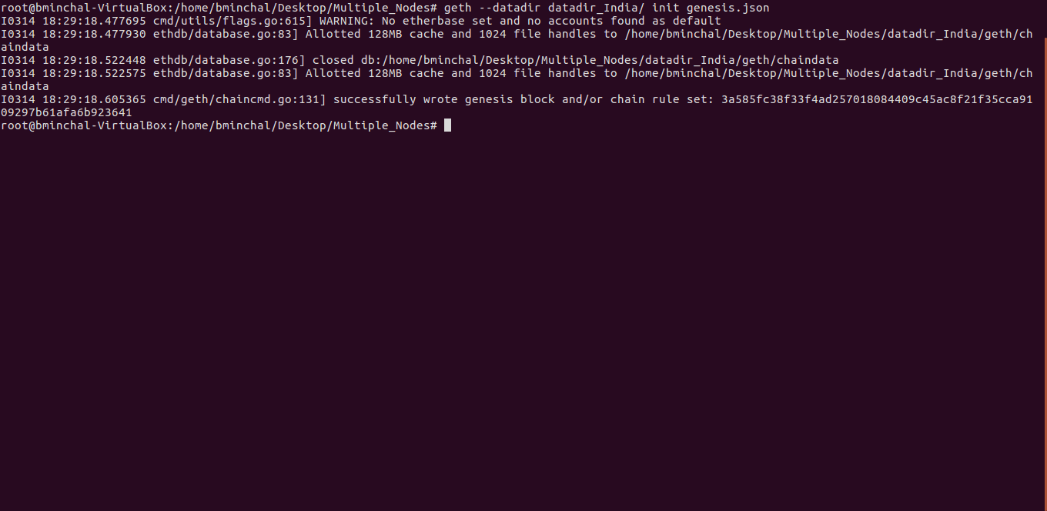

* Same way, initialize the genesis.json file for “datadir_USA” as below,

|  |
| --- |
| $ geth --datadir datadir_USA/ init genesis.json |

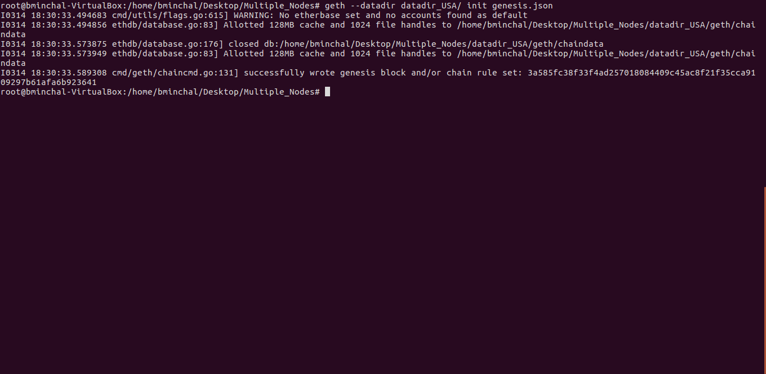

* Create accounts for node “datadir_India”,

|  |
| --- |
| $ geth --datadir datadir_India/ account new |

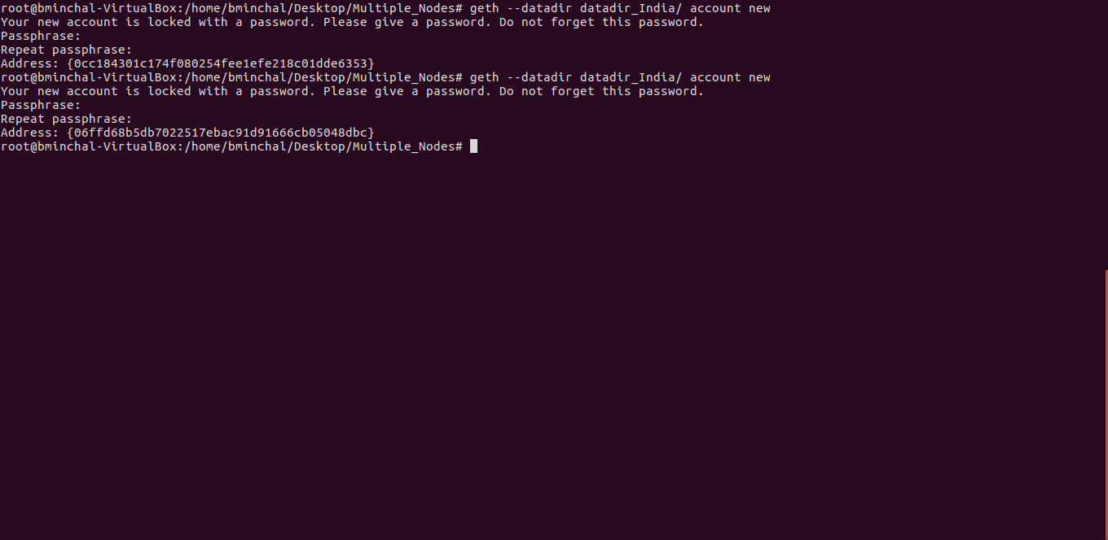

* Create accounts for node “datadir_USA”,

|  |
| --- |
| $geth --datadir datadir_USA/ account new |

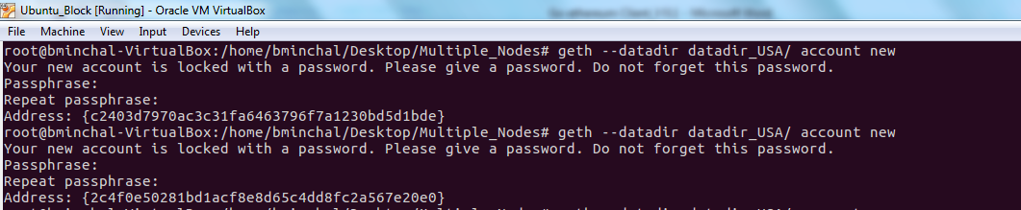

* Update the genesis.json file with newly created accounts of both “datadir_India” & “datadir_USA”,

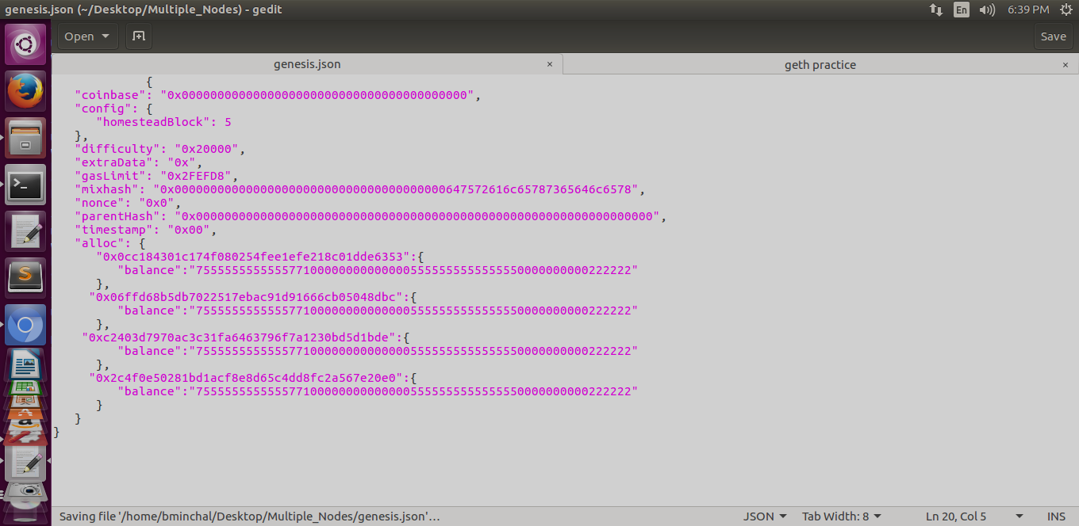

* Again initialize the genesis.json file for both “datadir_India” & “datadir_USA”,

|  |
| --- |
| $ geth --datadir datadir_India/ init genesis.json  $ geth --datadir datadir_USA/ init genesis.json |

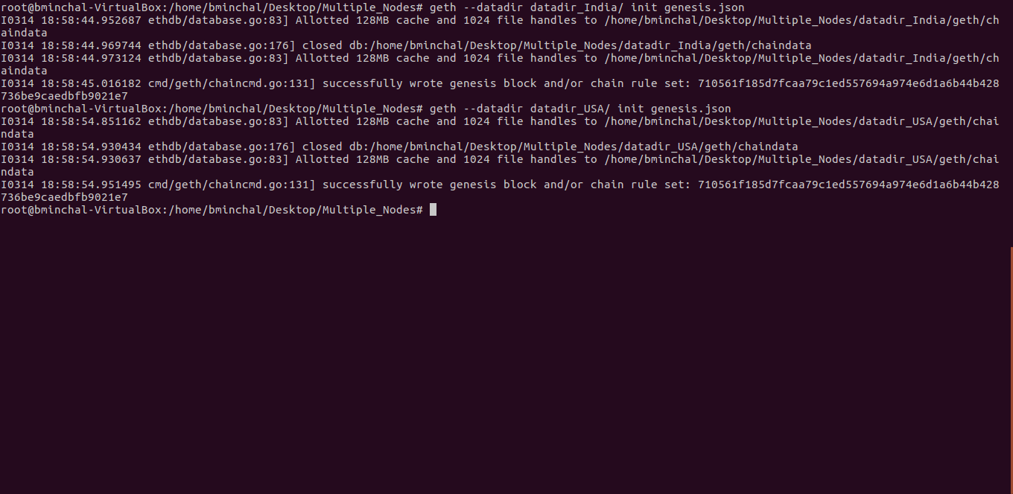

***Running the multiple nodes locally:***

***Node 1:***

* Run the node 1 (“PrivateNodeIndia”) under port “61916” in one terminal,

|  |
| --- |
| geth --identity "PrivateNodeIndia" --rpc --rpcport "7898" --rpccorsdomain "*" --datadir "datadir_India/" --port "61916" --nodiscover --ipcapi "admin,db,eth,debug,miner,net,shh,txpool,personal,web3" --rpcapi "db,eth,net,web3" --autodag --networkid 3141592 --maxpeers 3 --nat "any" --etherbase "0x0cc184301c174f080254fee1efe218c01dde6353" --unlock 0,1 console |

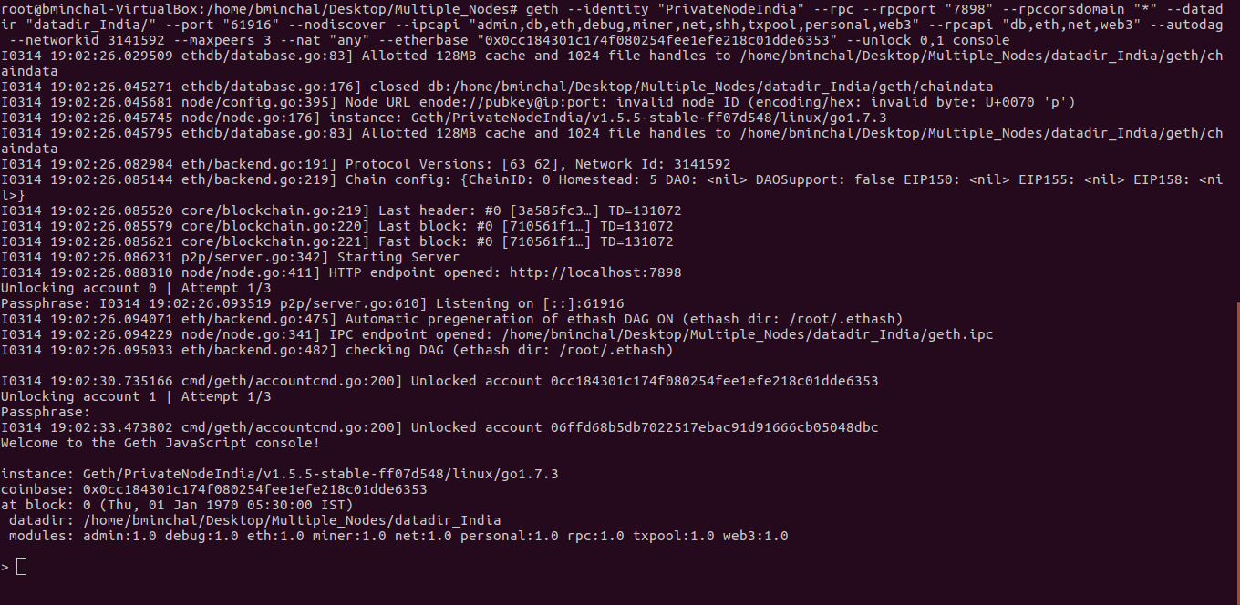

* Run the command “admin.nodeInfo.enode” in the console, to get the node information

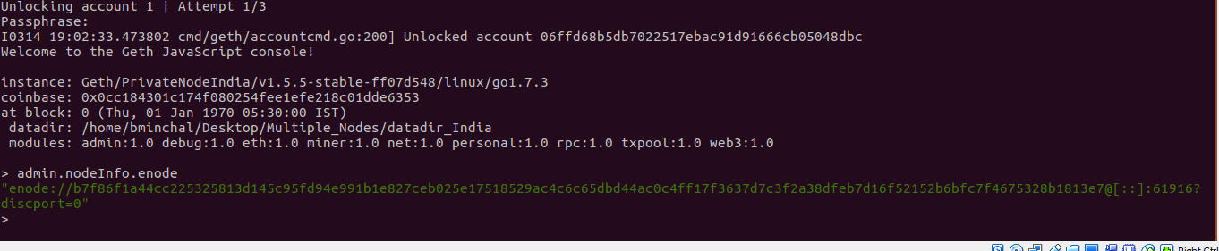

***Node 2:***

* Run the node 2(“PrivateNodeUSA”) under port “61917” in another terminal,

|  |
| --- |
| geth --identity "PrivateNodeUSA" --rpc --rpcport "7890" --rpccorsdomain "*" --datadir "datadir_USA/" --port "61917" --nodiscover --ipcapi "admin,db,eth,debug,miner,net,shh,txpool,personal,web3" --rpcapi "db,eth,net,web3" --autodag --networkid 3141592 --maxpeers 3 --nat "any" --etherbase "0xc2403d7970ac3c31fa6463796f7a1230bd5d1bde" --unlock 0,1 console |

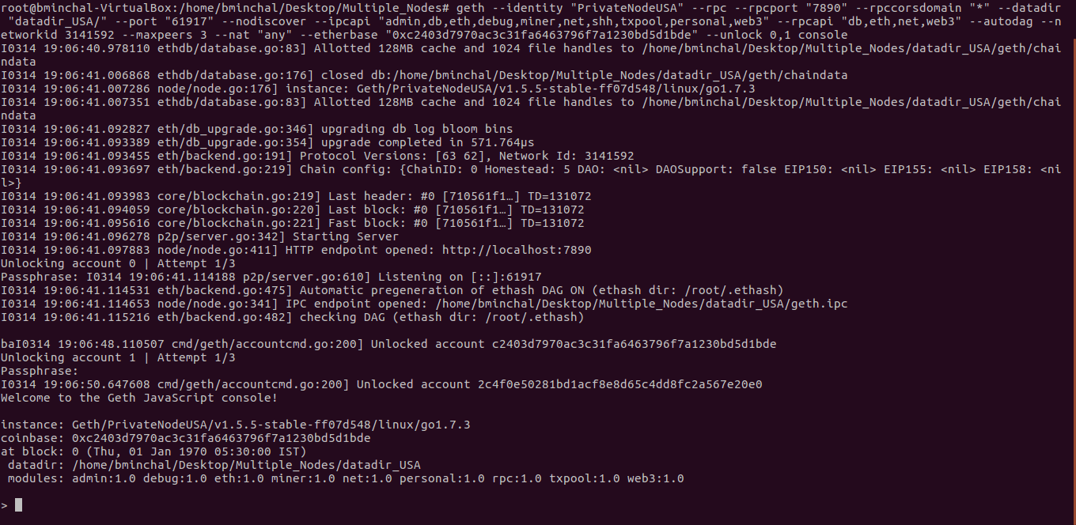

* Check the console with below command which should be set to true,

|  |
| --- |
| >net.listening |

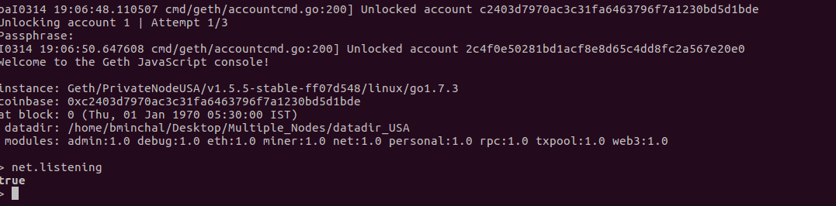

* Add the peer (“PrivateNodeIndia”) to node(“PrivateNodeUSA”) using the node info of “PrivateNodeIndia” as below,

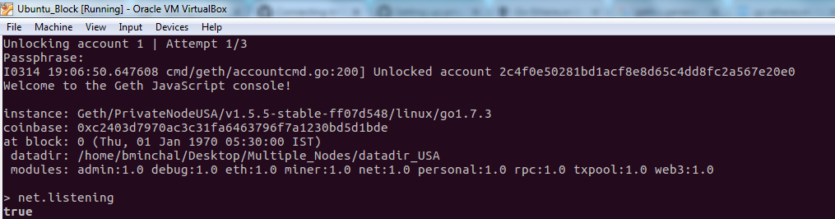

* Add the peers using command,

|  |
| --- |
| >admin.addPeer(nodeinfo of india) |



* Check for connected peers details using command,

|  |
| --- |
| >admin.peers |

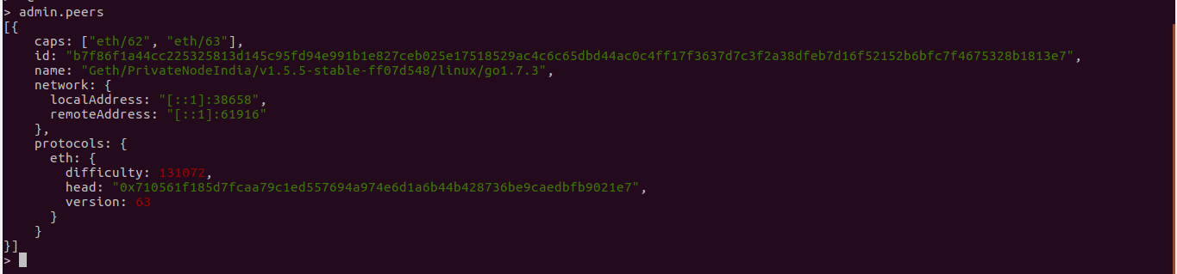

* Now both peers are connected each other successfully, so that data available of “Private Node India” can be accessed in “Private Node USA” and viceversa.

**Ethereum Installation steps in windows*:***

## Prerequisites:

Below are the software’s to be installed for running ethereum on windows

**NPM & NODEJS:**

## Installation Steps

* **Download the Windows installer from the** [Nodes.js® web site](http://nodejs.org/)[**http://nodejs.org/**](http://nodejs.org/)

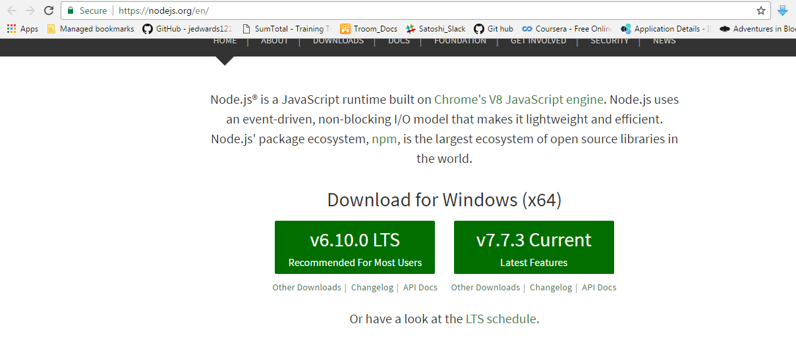

* **Run the installer** (the .msi file you downloaded in the previous step.)
* **Follow the prompts in the installer** (Accept the license agreement, click the NEXT button a bunch of times and accept the default installation settings).  
  [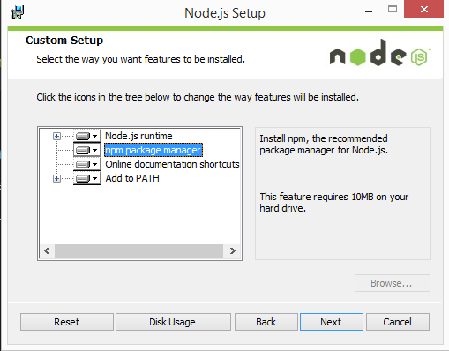](http://blog.teamtreehouse.com/wp-content/uploads/2015/01/installer.png)
* **Restart your computer.** You won’t be able to run Node.js® until you restart your computer.

**GIT:**

### Git for Windows stand-alone installer:

1. Download the latest [Git for Windows installer](https://git-for-windows.github.io/) <https://git-for-windows.github.io/>
2. When you've successfully started the installer, you should see the **Git Setup** wizard screen. Follow the **Next** and **Finish** prompts to complete the installation. The default options are pretty sensible for most users.
3. Open a Command Prompt (or Git Bash if during installation you elected not to use Git from the Windows Command Prompt).
4. Run the following commands to configure your Git username and email using the following commands, replacing Emma's name with your own. These details will be associated with any commits that you create:

$ git config --global user.name "Emma Paris"

$ git config --global user.email "eparis@atlassian.com"

**METEOR:**

1. Visit [meteor.com/install](http://meteor.com/install) and download the .exe file for Installing Meteor on Windows.

**ETHEREUM USING GETH:**

1. There is an [Installer for Windows](http://www.ethdocs.org/en/latest/ethereum-clients/cpp-ethereum/installing-binaries/windows-installer.html) in the link <https://geth.ethereum.org/downloads>
2. Download the installer for 64-bit windows,

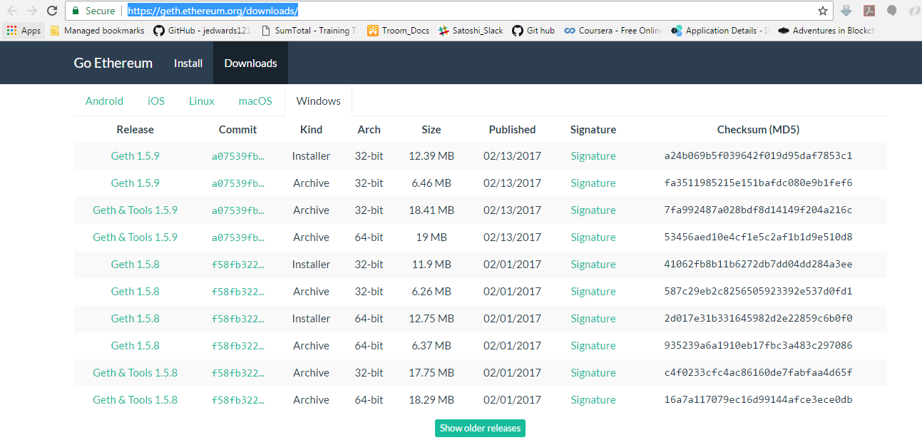

.

***Running Ethereum on windows:***

* Create a new directory “datadir” and a .json file as genesis.json

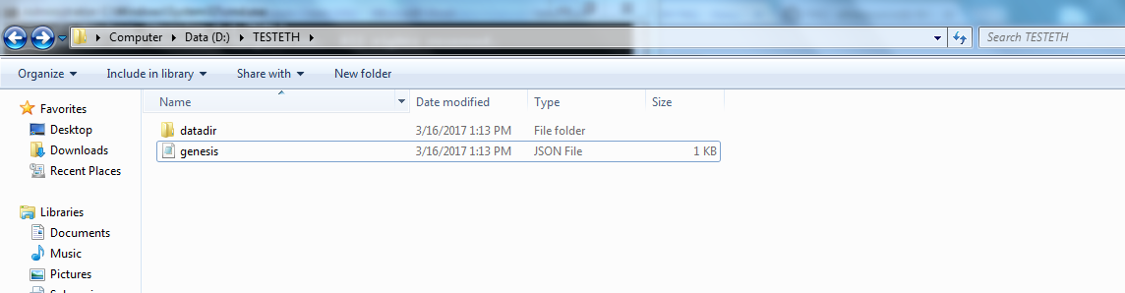

* Create the genesis.json file using the below data

|  |
| --- |
| {  "coinbase": "0x0000000000000000000000000000000000000000",  "config": {  "homesteadBlock": 5  },  "difficulty": "0x20000",  "extraData": "0x",  "gasLimit": "0x2FEFD8",  "mixhash": "0x00000000000000000000000000000000000000647572616c65787365646c6578",  "nonce": "0x0",  "parentHash": "0x0000000000000000000000000000000000000000000000000000000000000000",  "timestamp": "0x00",  "alloc": {  "0xfb210691802af09c0247ad712b48eedfedcbda42":{  "balance":"7555555555555771000000000000005555555555555550000000000222222"  },  "0x793eeaa9f3e204ab3b7ecb96ea05ef9c9b2b8ac5":{  "balance":"7555555555555771000000000000005555555555555550000000000222222"  }  } |

* Initialize the newly created data directory with genesis.json file, using below command,

|  |
| --- |
| geth –datadir datadir init genesis.json |

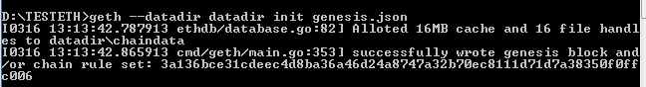

* After initializing the below chain data will be created.

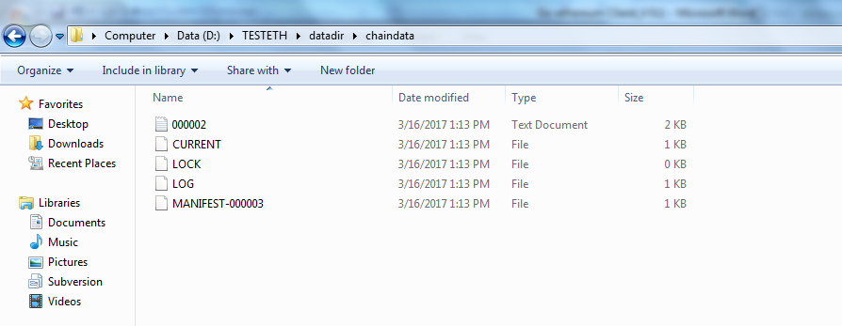

* Now you need to create accounts for the newly created data directory as below

|  |
| --- |
| geth –datadir datadir account new |

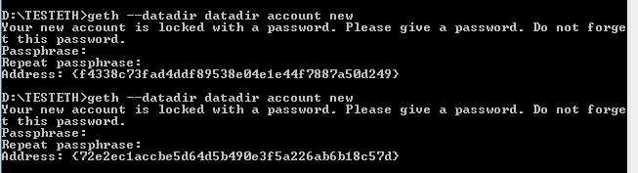

* After creating accounts, key store directory will be updated with password protected key files.

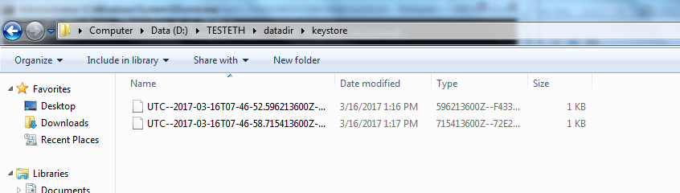

* Now update the genesis.json file with newly created accounts,

|  |
| --- |
| {  "coinbase": "0x0000000000000000000000000000000000000000",  "config": {  "homesteadBlock": 5  },  "difficulty": "0x20000",  "extraData": "0x",  "gasLimit": "0x2FEFD8",  "mixhash": "0x00000000000000000000000000000000000000647572616c65787365646c6578",  "nonce": "0x0",  "parentHash": "0x0000000000000000000000000000000000000000000000000000000000000000",  "timestamp": "0x00",  "alloc": {  "0xf4338c73fad4ddf89538e04e1e44f7887a50d249":{  "balance":"7555555555555771000000000000005555555555555550000000000222222"  },  "0x72e2ec1accbe5d64d5b490e3f5a226ab6b18c57d":{  "balance":"7555555555555771000000000000005555555555555550000000000222222"  }  }  } |

* Now again initialize the data directory with newly updated accounts on genesis.json ,

|  |
| --- |
| $geth --datadir datadir init genesis.json |

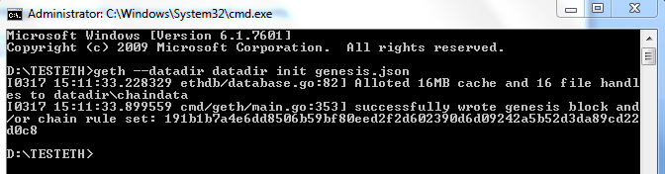

* Now run the go-ethereum under port 8545 for the newly data directory ,

|  |
| --- |
| geth --identity "PrivateNode" --rpc --rpcport "8545" --rpccorsdomain "*" --datadir "datadir/" --port "30303" --nodiscover –ipcapi "admin,db,eth,debug,miner,net,shh,txpool,personal,web3" --rpcapi "db,eth,net,web3" --autodag --networkid 1900 --nat "any" --etherbase "0xf4338c73fad4ddf89538e04e1e44f7887a50d249" --unlock 0,1 --mine |

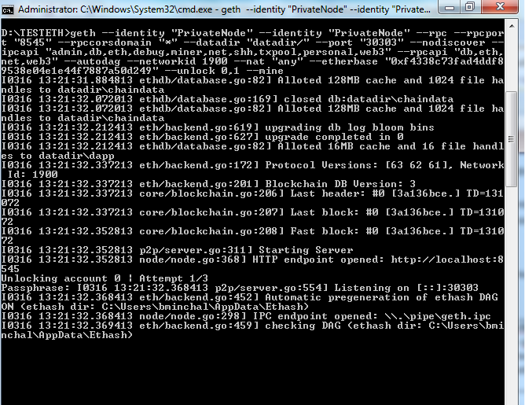

* Please enter the password for unlocking the accounts 0 & 1,

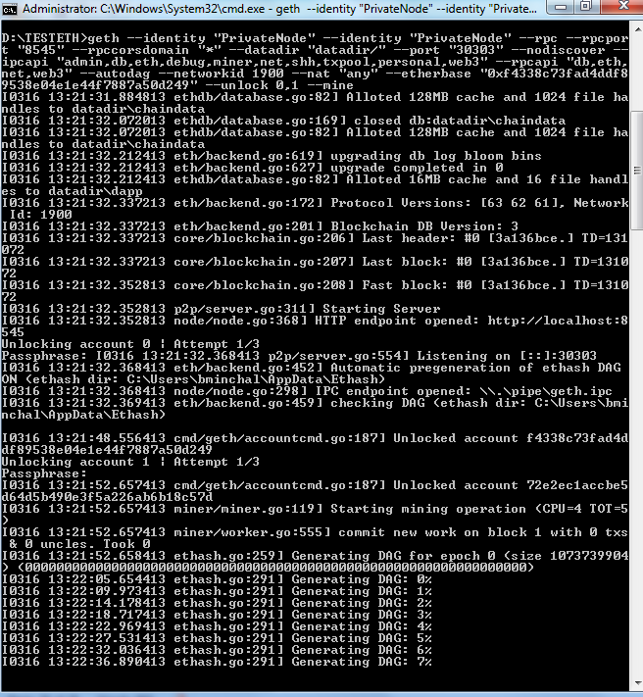

Below is the example for testing the ethereum,

**Note:** The geth client should be running for testing this example



* Go to examples folder and open contract.html file,

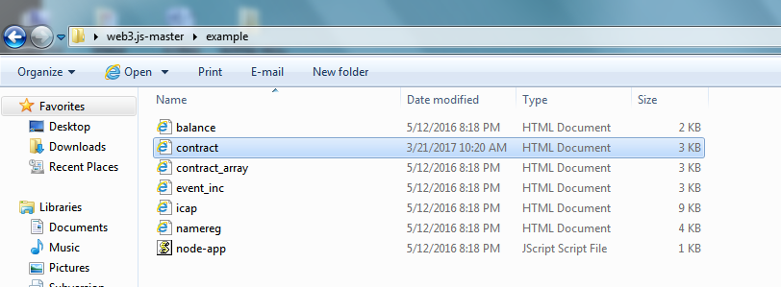

* Click on create contract button for creating a new contract on chain,

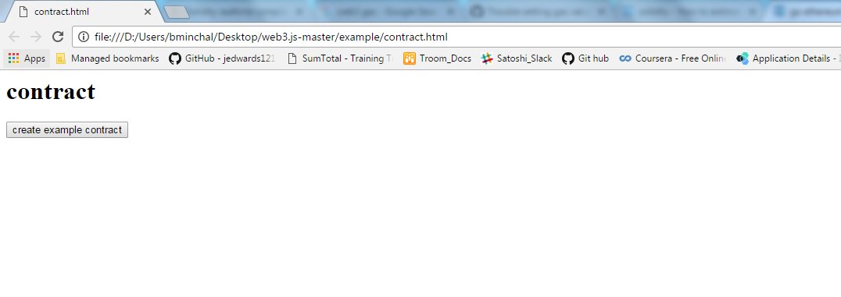

* Once you click on the “create example contract”, the contract will be created on the ethereum block chain as shown below,

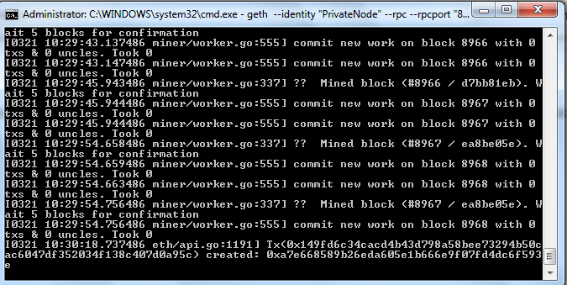

* After creating a contract, it will be mined and stored inside the blocks,

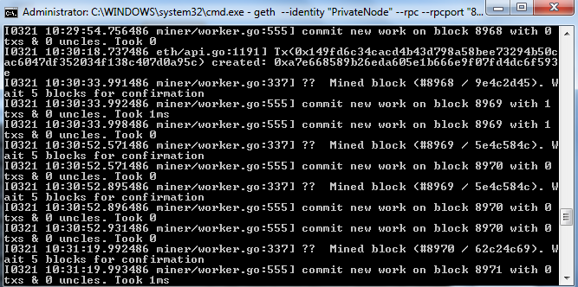

* The below message will be displayed after the contract is successfully mined on network.

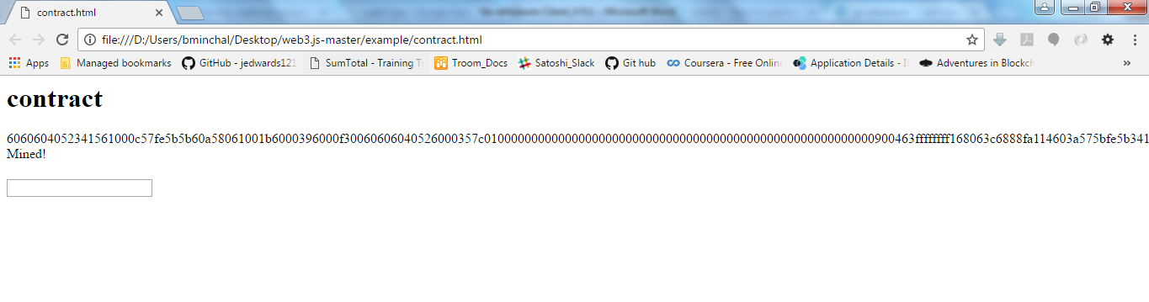

Below is not working in windows

***Running multiple nodes locally:***

***Prerequisites:***

* Create two new folders as “datadir_India” and “datadir_USA”,

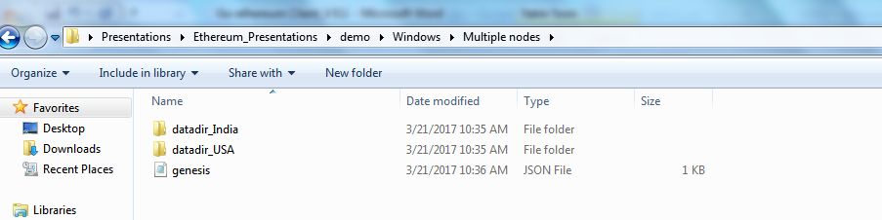

* Create a common genesis.json file for both nodes as below,

|  |
| --- |
| {  "coinbase": "0x0000000000000000000000000000000000000000",  "config": {  "homesteadBlock": 5  },  "difficulty": "0x20000",  "extraData": "0x",  "gasLimit": "0x2FEFD8",  "mixhash": "0x00000000000000000000000000000000000000647572616c65787365646c6578",  "nonce": "0x0",  "parentHash": "0x0000000000000000000000000000000000000000000000000000000000000000",  "timestamp": "0x00",  "alloc": {  "0xcd5e607784b54b91c2ca3b3fb1556253f0108288":{  "balance":"7555555555555771000000000000005555555555555550000000000222222"  },  "0xb0877c066e4c4863d1d2d42eda87ff896c4f6572":{  "balance":"7555555555555771000000000000005555555555555550000000000222222"  }  }  } |

* Initialize the genesis.json file for “datadir_India” as below,

|  |
| --- |
| geth --datadir datadir_India/ init genesis.json |

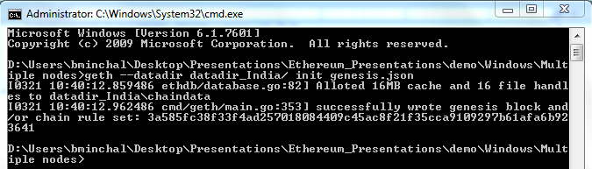

* Same way, initialize the genesis.json file for “datadir_USA” as below,

|  |
| --- |
| geth --datadir datadir_USA/ init genesis.json |

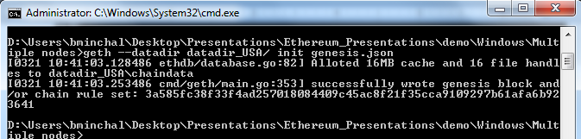

* Create accounts for node “datadir_India”,

|  |
| --- |
| geth --datadir datadir_India/ account new |

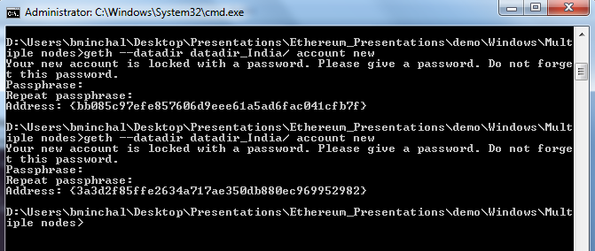

* Create accounts for node “datadir_USA”,

|  |
| --- |
| geth --datadir datadir_USA/ account new |

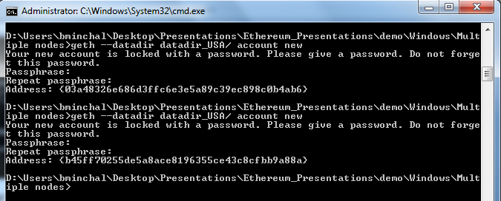

* Update the genesis.json file with newly created accounts of both “datadir_India” & “datadir_USA”,

|  |
| --- |
| {  "coinbase": "0x0000000000000000000000000000000000000000",  "config": {  "homesteadBlock": 5  },  "difficulty": "0x20000",  "extraData": "0x",  "gasLimit": "0x2FEFD8",  "mixhash": "0x00000000000000000000000000000000000000647572616c65787365646c6578",  "nonce": "0x0",  "parentHash": "0x0000000000000000000000000000000000000000000000000000000000000000",  "timestamp": "0x00",  "alloc": {  "0xbb085c97efe857606d9eee61a5ad6fac041cfb7f":{  "balance":"7555555555555771000000000000005555555555555550000000000222222"  },  "0xbb085c97efe857606d9eee61a5ad6fac041cfb7f":{  "balance":"7555555555555771000000000000005555555555555550000000000222222"  },  "0x03a48326e686d3ffc6e3e5a89c39ec898c0b4ab6":{  "balance":"7555555555555771000000000000005555555555555550000000000222222"  },  "0xb45ff70255de5a8ace8196355ce43c8cfbb9a88a":{  "balance":"7555555555555771000000000000005555555555555550000000000222222"  }  }  } |

* Again initialize the genesis.json file for both “datadir_India” & “datadir_USA”,

|  |
| --- |
| geth --datadir datadir_India/ init genesis.json  geth --datadir datadir_USA/ init genesis.json |

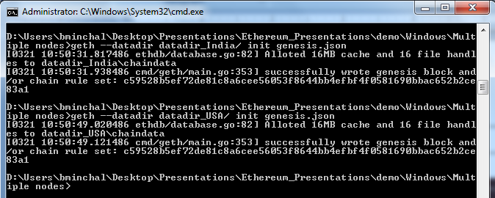

***Running the multiple nodes locally:***

***Node 1:***

* Run the node (“PrivateNodeIndia”) in one terminal,

|  |
| --- |
| geth --identity "PrivateNodeIndia" --rpc --rpcport "7898" --rpccorsdomain "*" --datadir "datadir_India/" --port "61916" --nodiscover --ipcapi "admin,db,eth,debug,miner,net,shh,txpool,personal,web3" --rpcapi "db,eth,net,web3" --autodag --networkid 3141592 --maxpeers 3 --nat "any" --etherbase "0xbb085c97efe857606d9eee61a5ad6fac041cfb7f" --unlock 0,1 console |

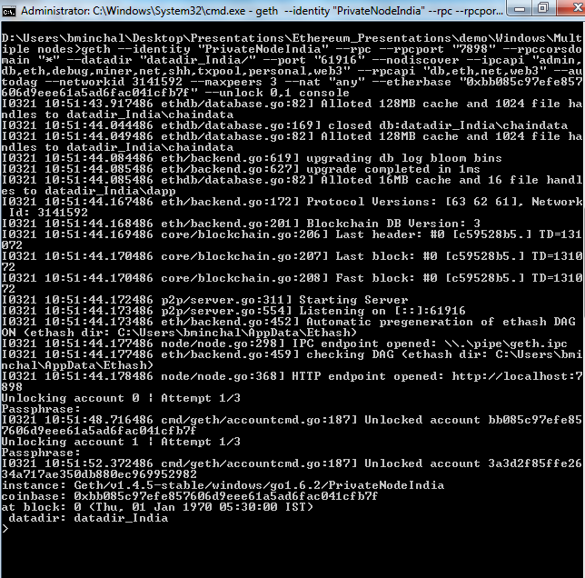

* Run the command in the console, to get the node information,

|  |
| --- |
| > admin.nodeInfo.enode |

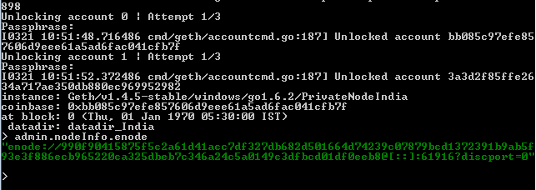

***Node 2:***

* Run the second node(“PrivateNodeUSA”) in another terminal,

|  |
| --- |
| geth --identity "PrivateNodeUSA" --rpc --rpcport "7890" --rpccorsdomain "*" --datadir "datadir_USA/" --port "61917" --nodiscover --ipcapi "admin,db,eth,debug,miner,net,shh,txpool,personal,web3" --rpcapi "db,eth,net,web3" --ipcdisable --autodag --networkid 3141592 --maxpeers 3 --nat "any" --etherbase "0x03a48326e686d3ffc6e3e5a89c39ec898c0b4ab6" --unlock 0,1 console |

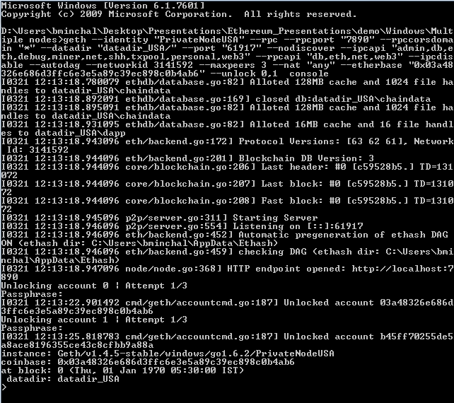

* Check the console of node “PrivateNodeUSA" with below command which should be set to true,

|  |
| --- |
| >net.listening |

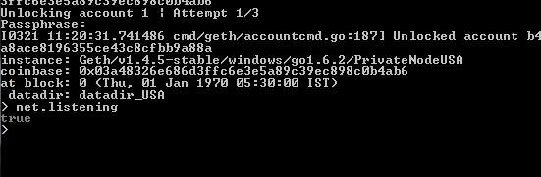

* Add the peer (“PrivateNodeIndia”) to node(“PrivateNodeUSA”) using the node info of “PrivateNodeIndia” using command,

|  |
| --- |
| >admin.addPeer(enodeinfo of india) |

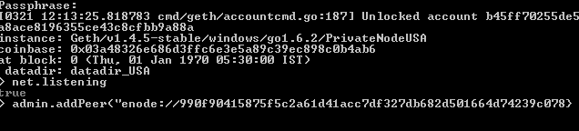

* Check for connected peers details using command,

|  |
| --- |
| >admin.peers |

* Now both peers are successfully connected so that you can access the contracts of node “PrivateNodeIndia” in node “PrivateNodeUSA” and viceversa.